Nebojša Simić
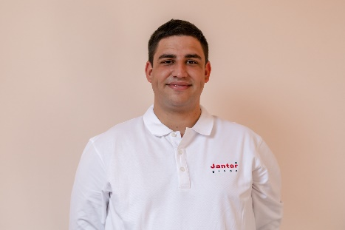
Nebojša Simić je geolog junior u kompaniji Jantar grupa d.o.o. Osnovne studije je završio 2017. god. stekavši zvanje bečelora geologije (Bch geologije), a trenutno se nalazi na završnoj godini master studija na Rudarsko-geološkom fakultetu Univerziteta u Beogradu. Počeo je da radi u kompaniji Jantar grupa u oktobru 2019. god., a pre toga kao saradnik na terenskim radovima).
U prethodnim godinama stekao je veliko iskustvo radom na terenu. Sarađivao je sa većim brojem kompanija na istraživanjima metala, nemetala kao i istraživanjima uglja. Ima iskustva kako sa svim geološkim terenskim programima i operacijama tako i sa logistikom pri izvođenju istih. U prethodnim godinama je pri istraživanjima samostalno vodio ekipe i upravljao radovima na terenu. Osim na terenskim istraživanjima uspešno sarađuje na pisanju projekata istraživanja, izveštaja o rezultatima istraživanja, elaborata o resursima i rezervama. Učestvovao je na različitim stručnim kongresima, seminarima i kursevima iz oblasti geologije.
Nebojša Simić is a junior geologist in Jantar grupa Ltd. He completed his basic studies in 2017. gaining the title of Bachelor of Geology (Bch Geology), and is currently in his final year of master's studies at the Faculty of Mining and Geology, University of Belgrade. He started working in Jantar Grupa in October 2019., while before that he participated in the field works in the same company.

In previous years he gained extensive experience working in the field. He has collaborated with a number of different companies on metallic, non-metallic mineral resources and coal research. He has experience both with geological field programs and operations and with logistics in performing them. He has independently led teams and managed field work in the same time. In addition to field research, he successfully collaborates on writing research projects, reports, resource and reserve estimations. He has participated in various professional congresses, seminars and courses.

